LIST OF COUNTRIES WITH STUDENTS TRAINED AT IFI
No | Countries | Flags | No | Countries | Flags
1 | Republic of Niger | 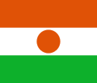 | 10 | Republic of Burundi | 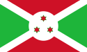
2 | Republic of Haiti | 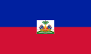 | 11 | Republic of Côte d’Ivoire | 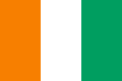
3 | Togolese Republic | 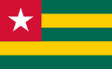 | 12 | Republic of Mali | 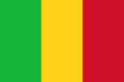
4 | Republic of Guinea | 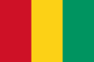 | 13 | Republic of Cameroon | 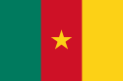
5 | Central African Republic | 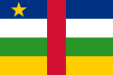 | 14 | Republic of Madagascar
6 | Republic of the Congo | 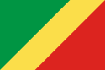 | 15 | Republic of Benin | 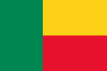
7 | Democratic Republic of the Congo | 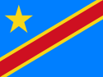 | 16 | Republic of Chad | 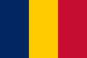

8 | Burkina Faso | 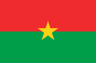 | 17 | Socialist Republic of Vietnam | 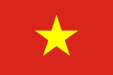
9 | Republic of Senegal | 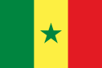 | 18 | People's Republic of China | 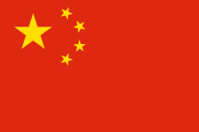
19 | Cambodia | 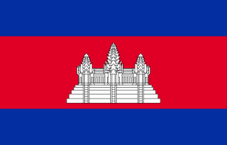 | 20 | Laos | 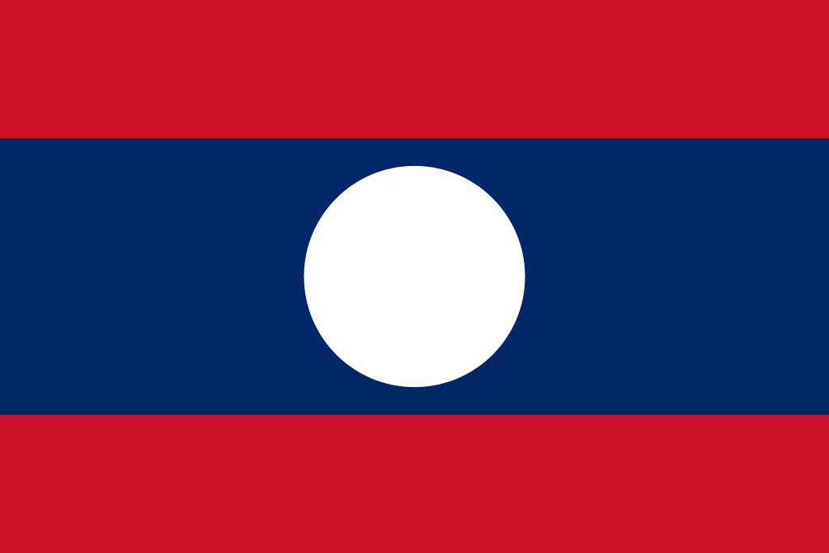
21 | Thailand | 